Appendix

Appendix 1- Flow chart showing example of lineage designation process and lineage classifications. Classifications can branch and change in either or a combination of the below paths. 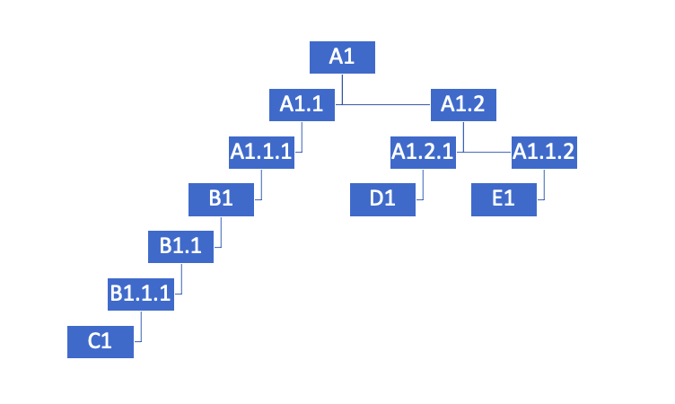

Appendix 2- data curation

Table 1 - Quantity of missing data before and after data curation.

|  |  |  |
| --- | --- | --- |
| Type of Data | Number of sequences missing data in original dataset | Number of sequences missing data in final dataset |
| Date (Year) | 54 | 36 |
| Country | 0 | 0 |
| Host | 12 | 2 |
| Pubmed ID | 247 | 163 |

Appendix 3- WGS vs partial table

Number of partial genome, whole genome and total sequences for each country.

|  |  |  |  |
| --- | --- | --- | --- |
| Country | Total | Partial Genome | Whole Genome |
| Cambodia | 172 | 167 | 5 |
| Indonesia | 80 | 79 | 1 |
| Laos | 27 | 21 | 6 |
| Myanmar | 9 | 7 | 2 |
| Philippines | 664 | 558 | 106 |
| Thailand | 526 | 522 | 4 |
| Vietnam | 100 | 99 | 1 |
| Malaysia | 18 | 18 | 0 |
| TOTAL | 1596 | 1471 | 125 |

Appendix 4

Sequences over time, annotated by sequence type. PGS are partial genome sequences and WGS are whole genome sequences.

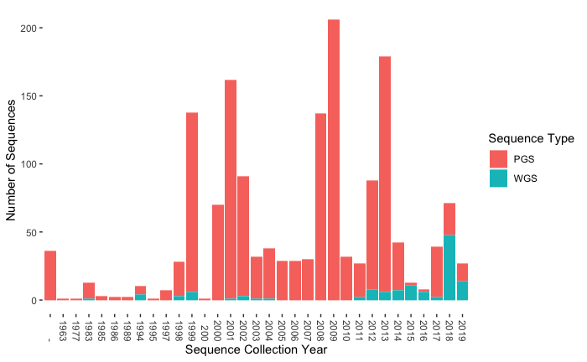

Appendix 5

Number of sequences per genome region per country

|  |  |  |  |  |  |  |
| --- | --- | --- | --- | --- | --- | --- |
| Country | WGS | N | G | P | L | M |
| Philippines | 105 | 187 | 532 | 150 | 113 | 106 |
| Thailand | 3 | 409 | 65 | 16 | 5 | 28 |
| Vietnam | 1 | 64 | 33 | 1 | 5 | 1 |
| Myanmar | 2 | 5 | 3 | 2 | 5 | 2 |
| Laos | 6 | 23 | 7 | 6 | 9 | 6 |
| Cambodia | 5 | 161 | 10 | 5 | 11 | 5 |
| Malaysia | 0 | 18 | 0 | 0 | 0 | 0 |
| Indonesia | 1 | 77 | 3 | 1 | 2 | 1 |
| TOTAL | 123 | 944 | 653 | 181 | 150 | 149 |

Appendix 6

Number of each host type per country in southeast Asia. “Exotic pet” category includes tiger, monkey, and deer.

|  |  |  |  |  |  |  |  |  |
| --- | --- | --- | --- | --- | --- | --- | --- | --- |
| Country | *Canis familiaris* | *Felis catus* | Exotic pet | *Homo sapien* | *Equus caballus* | *Sus scrofa* | *Capra hircus* | *Bos taurus* |
| Thailand | 467 | 12 | 0 | 29 | 1 | 0 | 0 | 0 |
| Indonesia | 55 | 10 | 3 | 8 | 0 | 1 | 2 | 0 |
| Philippines | 648 | 5 | 0 | 4 | 0 | 0 | 0 | 0 |
| Vietnam | 62 | 0 | 0 | 17 | 0 | 0 | 0 | 2 |
| Laos | 27 | 0 | 0 | 0 | 0 | 0 | 0 | 0 |
| Cambodia | 172 | 0 | 0 | 0 | 0 | 0 | 0 | 0 |
| Myanmar | 9 | 0 | 0 | 0 | 0 | 0 | 0 | 0 |
| Malaysia | 14 | 3 | 0 | 1 | 0 | 0 | 0 | 0 |

Appendix 7

Phylogeny annotated by host type. Zoomed in cluster of human cases in Vietnam (A) and various hosts in Indonesia (B) from N gene phylogeny.



Appendix 8

8A- Matrix table of symmetrical shared lineages within the N gene data set (unique lineages only, ex. If SEA-3_A1 is shared between Cambodia, Vietnam, and Laos, it will be shown as 1 (Cambodia-Vietnam), 1 (Vietnam-Laos), and 1(Cambodia-Laos)).

|  |  |  |  |  |  |  |  |  |
| --- | --- | --- | --- | --- | --- | --- | --- | --- |
|  |  |  |  |  |  |  |  |  |
|  | Philippines | Thailand | Vietnam | Indonesia | Laos | Malaysia | Cambodia | Myanmar |
| Philippines | 11 | 0 | 0 | 0 | 0 | 0 | 0 | 0 |
| Thailand |  | 2 | 2 | 0 | 2 | 1 | 1 | 0 |
| Vietnam |  |  | 3 | 1 | 1 | 1 | 3 | 0 |
| Indonesia |  |  |  | 4 | 0 | 0 | 0 | 0 |
| Laos |  |  |  |  | 2 | 1 | 1 | 0 |
| Malaysia |  |  |  |  |  | 1 | 1 | 0 |
| Cambodia |  |  |  |  |  |  | 7 | 0 |
| Myanmar |  |  |  |  |  |  |  | 1 |

8B- Matrix table of symmetrical shared lineages within the WGS gene data set (unique lineages only, ex. If SEA-3_A1 is shared between Cambodia, Vietnam, and Laos, it will be shown as 1 (Cambodia-Vietnam), 1 (Vietnam-Laos), and 1(Cambodia-Laos)).

|  |  |  |  |  |  |  |  |  |
| --- | --- | --- | --- | --- | --- | --- | --- | --- |
|  |  |  |  |  |  |  |  |  |
|  | Myanmar | Cambodia | Malaysia | Laos | Indonesia | Vietnam | Thailand | Philippines |
| Philippines | 0 | 0 | 0 | 0 | 0 | 0 | 0 | 13 |
| Thailand | 1 | 1 | 0 | 1 | 0 | 1 | 0 |  |
| Vietnam | 0 | 0 | 0 | 0 | 0 | 0 |  |  |
| Indonesia | 0 | 0 | 0 | 0 | 0 |  |  |  |
| Laos | 0 | 1 | 0 | 0 |  |  |  |  |
| Malaysia | 0 | 0 | 0 |  |  |  |  |  |
| Cambodia | 0 | 0 |  |  |  |  |  |  |
| Myanmar | 0 |  |  |  |  |  |  |  |

Appendix 9

N gene phylogeny. Tip is colored by country and labeled with lineage. Resolution is available at a zoomed in level.



Appendix 10

WGS Philippines phylogeny. Tip is colored by island group.

